Equipment Performance Measurements
For

WAHT
1560 kHz

Cowpens SC
FCC ID 24482
October 17, 2019

Measurements taken by
Alan Alsobrook
Alsobrook Electronics
13 Matanzas Cir.
St. Augustine Fl. 32080
(904) 829-8885

General

These pages document the procedures and results of the measurements required by title 47 section 73.1590, as specified in section 73.44 of the Code of Federal Regulations, to demonstrate compliance with in-band emission requirements, and for harmonic content.

Measurement Procedure

A swept frequency RF spectrum analyzer with a resolution of 30 Hz, using a peak hold of a minimum of 10 minutes was used for these measurements. The signal was received off air with an untuned shielded loop antenna at a distance of approximately 1-kilometer from the antenna site. In-band emissions removed from the carrier by more than 40 kHz, as well as checks for harmonic content were made with a precision communications receiver. All measurements were made during daylight hours for all modes of operation.

Equipment list

Spectrum Analyzer Anritsu MS2721B
Precision Communications Receiver Potomac Fim-41
Antenna AE-LA2

Technical Qualifications

All measurements were made by Alan Alsobrook, who is a Certified Senior Radio Engineer #3338 by the SBE, and also holds FCC General Radio Telephone Operators License PG-6-11216. Mr. Alsobrook has served as a Radio Engineer since 1977.

Alan H Alsobrook

NDA-Day

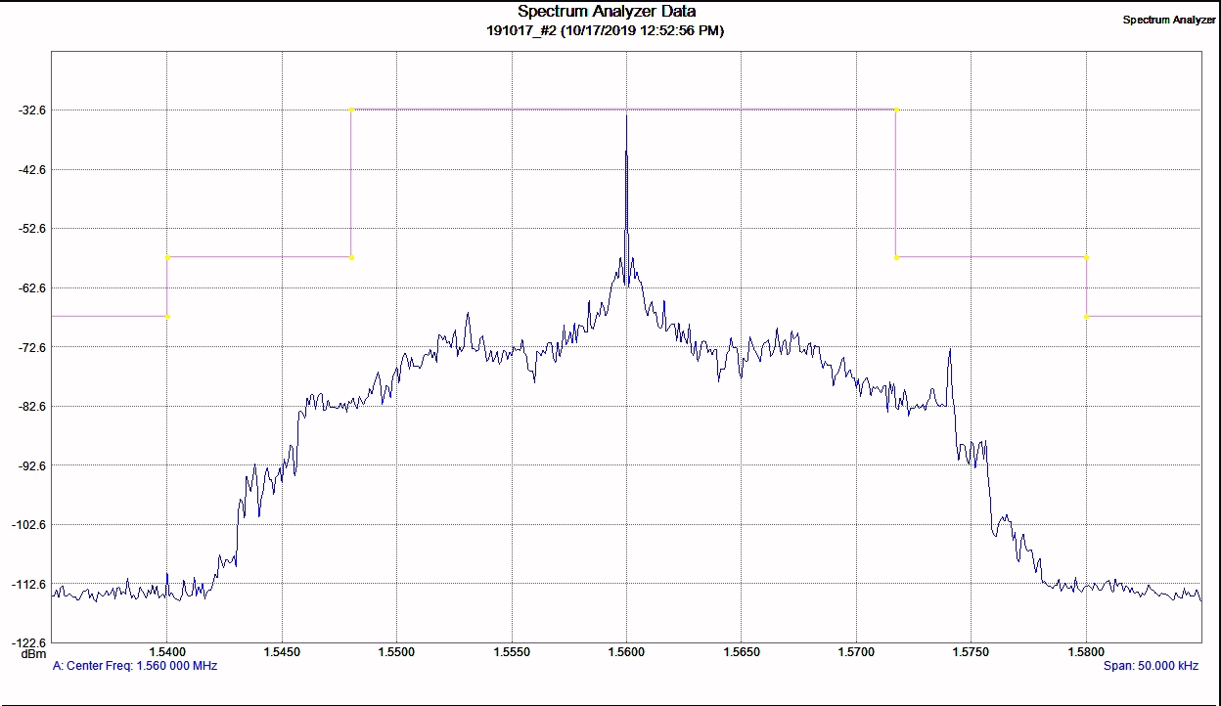

Horizontal 5kHz/Div. Vertical 10db/Div RBW 30Hz

73.44 (b) Attenuation of emissions below unmodulated carrier.

Range Requirement Measured

10.2 to 20kHz -25db -40db

Frequency Measurement 1560.001 kHz Error +1 Hz

NDA-Day

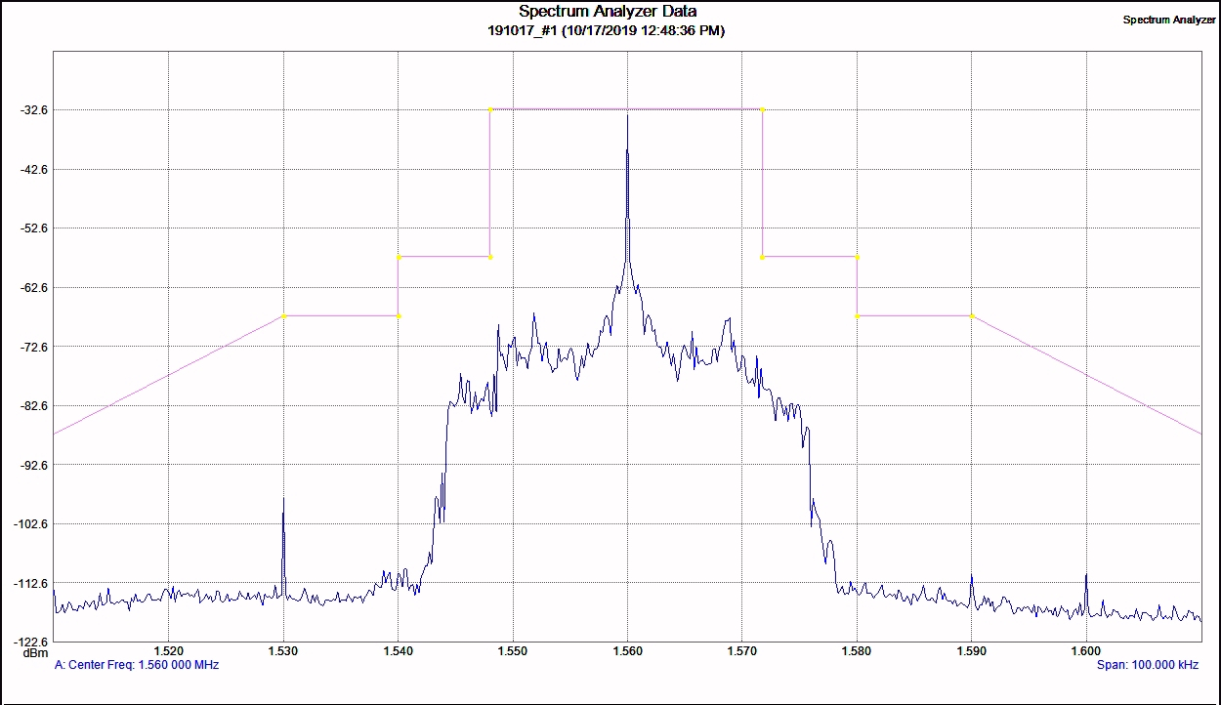

Horizontal 10kHz/Div. Vertical 10db/Div RBW 30Hz

73.44 (b) Attenuation of emissions below unmodulated carrier.

Range Requirement Measured

20 to 30kHz -35db -57db

30 to 60kHz 5 + 1db/khz Compliant

60 to 75kHz -65db -83 db

Beyond 75 kHz, The lesser of 80db or
43 + 10 Log (Power in watts)

NDA-Day

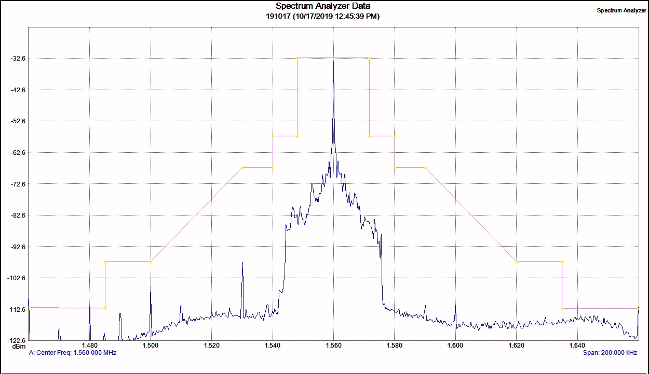

Horizontal 20 kHz/Div. Vertical 10db/Div RBW 30Hz

73.44 (b) Attenuation of emissions below unmodulated carrier.

Beyond 75 kHz = 80 dB

Using the receiver section of the IFR Com 120 b the spectrum was swept from 535 kHz – 5000 kHz, the following readings were obtained.

In band spurs (535 kHz – 1705 kHz) Not detected

2nd harmonic 3120 kHz -83 dB

3rd Harmonic 4680 kHz -84 dB

4th Harmonic 6240 kHz Not detected

5th Harmonic 7800 kHz Not detected

